Church Staff
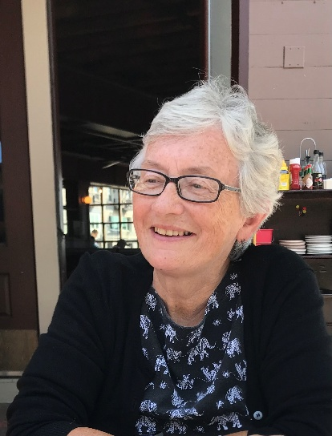

Rev. Ellen Parsons Tatreau

The Rev. Ellen Parsons Tatreau is
a retired , Ordained American
Baptist Minister. She and her
Husband, live in North Weymouth, MA. Rev. Tatreau has served Massachusetts in Framingham, New Bedford and Martha’s Vineyard as well as in Albany, New York. In retirement she has served as an Interim Pastor and supply Preacher in both American Baptist and United Church of Christ denominations.

